**Unit-3**

**Fuzzy Sets:** Fuzzy versus Crisp, Crisp Sets, Fuzzy sets, Membership functions, fuzzy set operations, properties of Fuzzy sets, Crisp Relations, Fuzzy relations

**Fuzzy Logic and Inference:** Crisp Logic, Predicate Logic, Fuzzy Logic, Fuzzy Quantifiers, Fuzzy Inference, Fuzzy knowledge and rule-based system, fuzzy decision making, Defuzzification.

**Fuzzy Logic**

Fuzzy logic is a type of logic that deals with reasoning and decision-making in situations where uncertainty, imprecision (lacks precision or exactness), and vagueness are present. Unlike classical (binary) logic, which uses "true" or "false" values, fuzzy logic allows for a range of truth values between 0 and 1, representing degrees of truth.

The concept of fuzzy logic was introduced by Lotfi Zadeh in the 1960s as a way to model human reasoning, which often involves dealing with vague or ambiguous information. Fuzzy logic is particularly useful in systems where precise mathematical modeling is challenging, and it has applications in various fields, including control systems, artificial intelligence, decision-making, and pattern recognition.

In fuzzy logic, variables can take on values that are not just true or false but can be partially true or partially false, reflecting the degree of membership in a particular set. Fuzzy sets and fuzzy rules are used to capture and represent the imprecision in the information.

One common application of fuzzy logic is in fuzzy control systems, where it is used to control complex systems that may have uncertain or imprecise inputs. Fuzzy logic has also been applied in consumer electronics, automotive systems (such as automatic transmissions), and other areas where imprecise information needs to be processed effectively.

**Fuzzy Sets**

**Crisp Sets:** also known as classical sets, adhere to the traditional binary logic where elements either belong or do not belong to a set.

* Membership in a crisp set is characterized by a clear boundary, and it is either 0 or 1.

Example: Consider the set A of all positive integers less than 10.

A={1, 2, 3, 4, 5, 6, 7, 8, 9}

An element like 7 is a member of set A (membership degree = 1),

while an element like 15 is not a member (membership degree = 0).

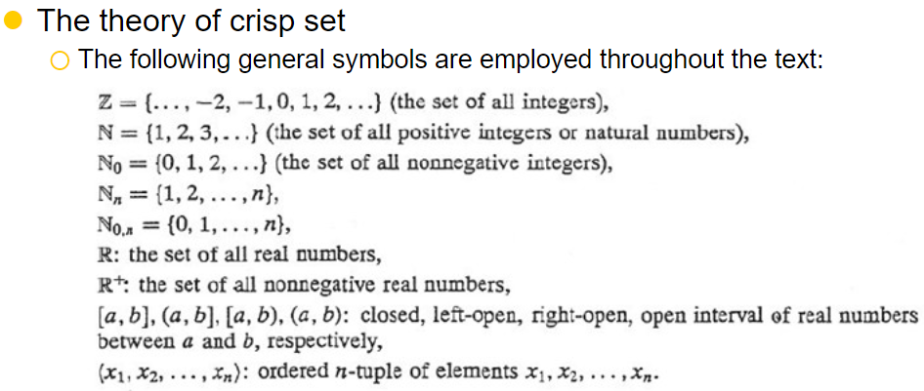

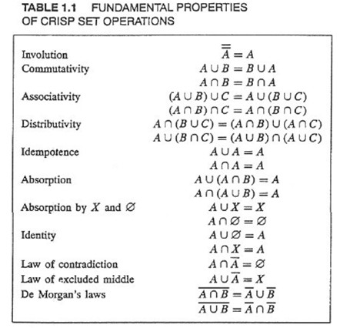

In crisp set theory, an involution operation is an operation that, when applied twice, returns the original element. Essentially, it's a self-inverse operation. One common example of an involution operation is the logical negation (NOT) operation.

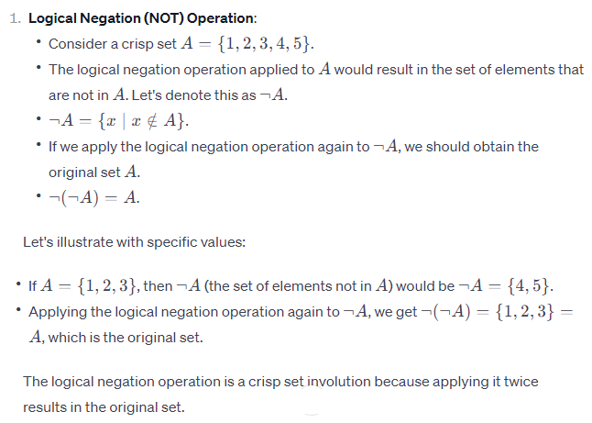

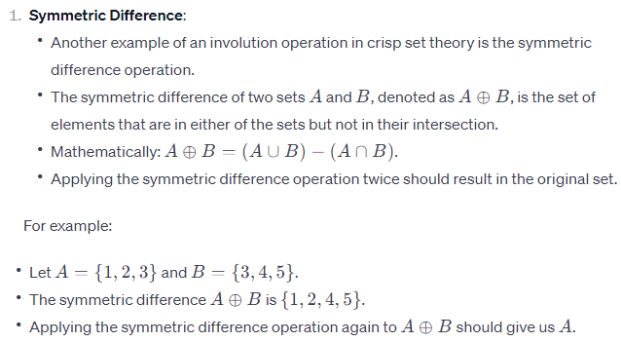

**Fuzzy Sets:** Fuzzy sets, introduced by Lotfi Zadeh, allow for degrees of membership between 0 and 1, providing a more flexible and nuanced approach to set membership. The degree of membership indicates the strength of the element belonging to the set.

* Elements can belong to a fuzzy set to varying degrees, reflecting the uncertainty or imprecision in the definition of the set.

Mathematically,

A fuzzy set A in a universe of discourse X is mathematically represented by its membership function μA(*x*), which assigns a degree of membership to each element *x* in X.

The membership function μA(*x*) maps elements from X to the interval [0, 1], indicating the degree to which *x* belongs to A.

A= {(*x*, μA(x)) ∣ *x*∈X}

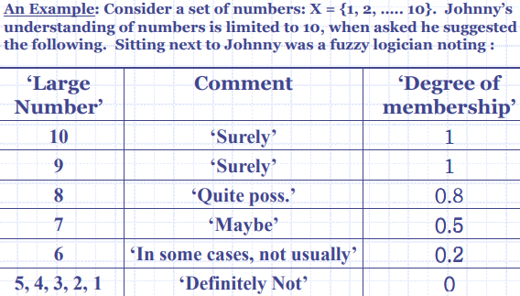

|  |  |  |
| --- | --- | --- |
| **S.No** | **Crisp Set** | **Fuzzy Set** |
| 1 | Crisp set defines the value is either 0 or 1. | Fuzzy set defines the value between 0 and 1 including both 0 and 1. |
| 2 | It is also called a classical set. | It specifies the degree to which something is true. |
| 3 | It shows full membership | It shows partial membership. |
| 4 | Eg1. She is 18 years old.  Eg2. Rahul is 1.6m tall | Eg1. She is about 18 years old.  Eg2. Rahul is about 1.6m tall. |
| 5 | Crisp set application used for digital design. | Fuzzy set used in the fuzzy controller. |
| 6 | It is bi-valued function logic. | It is infinite valued function logic |
| 7 | Full membership means totally true/false, yes/no, 0/1. | Partial membership means true to false, yes to no, 0 to 1. |

**Membership Functions**

In fuzzy logic, membership functions are mathematical functions that define the degree of membership of an element in a set. These functions are crucial in representing linguistic variables in fuzzy logic systems, where variables may have imprecise or vague boundaries. Here's an explanation along with examples:

1. **Linguistic Variables**:
   * In traditional logic, variables are crisp or precise, taking only true or false values.
   * In fuzzy logic, variables are linguistic, meaning they represent concepts with fuzzy boundaries like "tall," "hot," or "young."
2. **Membership Functions**:
   * Membership functions assign a degree of membership to each element in the universe of discourse.
   * The degree of membership indicates the extent to which an element belongs to a particular set.
   * These functions map input values to membership degrees in the range [0, 1].

**Examples:**

Example 1: Temperature Control System

Let's consider a temperature control system with linguistic variables for "temperature":

* Cold
* Warm
* Hot

For each linguistic variable, we define membership functions:

* **Cold**:
  + Membership function might look like a triangular function, peaking at a certain low temperature.
  + For example, if we consider "cold" to be between 0°C and 10°C, a temperature of 5°C might have a membership degree of 0.5.
* **Warm**:
  + Here, the membership function might peak around a moderate temperature.
  + If we consider "warm" to be between 15°C and 25°C, a temperature of 20°C might have a membership degree of 1.0.
* **Hot**:
  + Membership function peaks at high temperatures.
  + If "hot" is considered to be between 30°C and 40°C, a temperature of 35°C might have a membership degree of 0.8.

Example 2: Speed Control in a Car

Consider a car's speed control system with linguistic variables for "speed":

* Slow
* Moderate
* Fast
* **Slow**:
  + Membership function could be triangular, peaking at low speeds.
  + If "slow" is considered to be between 0 km/h and 40 km/h, a speed of 20 km/h might have a membership degree of 0.5.
* **Moderate**:
  + Membership function might peak around average speeds.
  + If "moderate" is considered to be between 30 km/h and 70 km/h, a speed of 50 km/h might have a membership degree of 1.0.
* **Fast**:
  + Membership function peaks at high speeds.
  + If "fast" is considered to be between 60 km/h and 120 km/h, a speed of 90 km/h might have a membership degree of 0.7.

In both examples, membership functions allow us to fuzzily represent and reason about variables that have imprecise or vague boundaries, making fuzzy logic suitable for systems that deal with human-like reasoning or uncertainties.

<https://codecrucks.com/what-is-fuzzy-membership-function-complete-guide/>

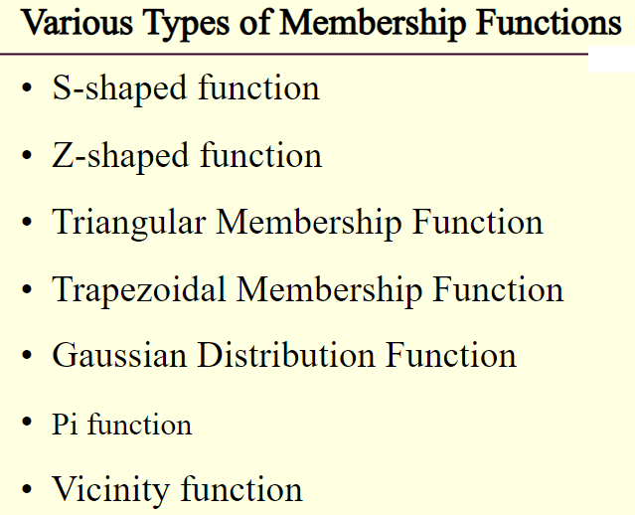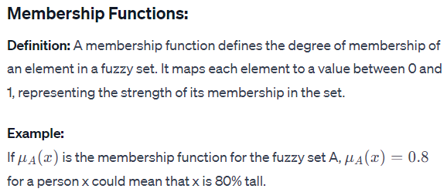

Membership functions in fuzzy logic come in various shapes and types, each suited for different types of linguistic variables and applications. Here are some common types of membership functions:

**Triangular Membership Function:**

* This is the simplest form, shaped like a triangle.
* It is characterized by three parameters: the left boundary, the peak value, and the right boundary.
* It is commonly used when the linguistic variable has a symmetric shape.

Example: Representing the linguistic variable "temperature" with values ranging from cold to hot.

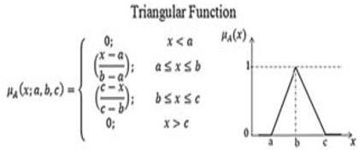

**Trapezoidal Membership Function:**

* Similar to the triangular membership function, but with parallel lines on the left and right sides, forming a trapezoid shape.
* It is characterized by four parameters: the left boundary, the left peak value, the right peak value, and the right boundary.
* It is useful for variables with fuzzy boundaries on both sides.

Example: Representing the linguistic variable "distance" with values ranging from near to far.

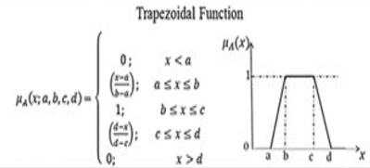

**Gaussian Membership Function:**

* Shaped like a bell curve.
* It is characterized by two parameters: the mean and the standard deviation.
* It is commonly used when the linguistic variable has a symmetric and smooth distribution.
* Example: Representing the linguistic variable "height" with values clustered around an average value.

**Generalized Bell Membership Function:**

* Similar to the Gaussian membership function but allows for asymmetry.
* It is characterized by three parameters: the shape parameter, the center parameter, and the width parameter.
* It is useful for variables with asymmetric distributions.
* Example: Representing the linguistic variable "income" with values skewed towards lower or higher incomes.

Sigmoidal (S-shaped) Membership Function:

Shaped like an S-curve.

It is characterized by two parameters: the slope and the midpoint.

It is useful for variables that exhibit a gradual transition from non-membership to membership.

Example: Representing the linguistic variable "satisfaction" with values ranging from unsatisfied to satisfied.

Singleton Membership Function:

Represents a single point in the universe of discourse.

It is characterized by a single parameter: the point value.

It is used when the linguistic variable has a precise, crisp value.

Example: Representing the linguistic variable "age" with a specific age value.

These are just a few examples of membership functions used in fuzzy logic. The choice of membership function depends on the nature of the linguistic variable being modeled and the specific requirements of the fuzzy logic system.

Top of Form

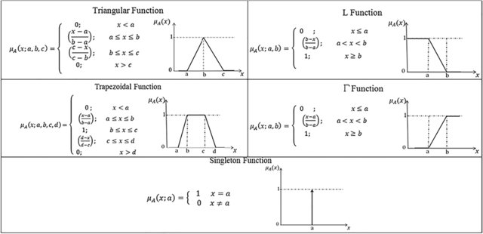

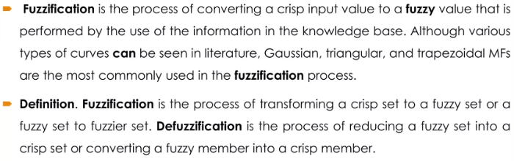

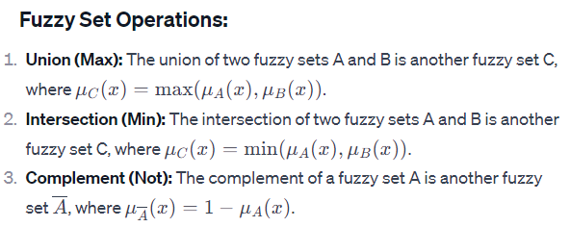

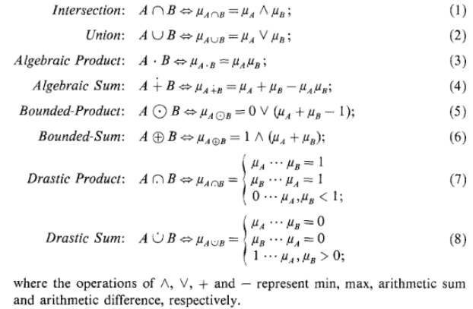

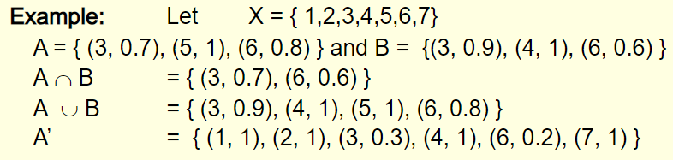

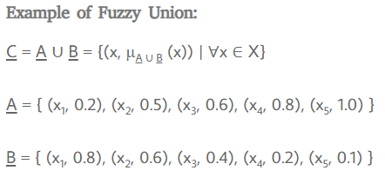

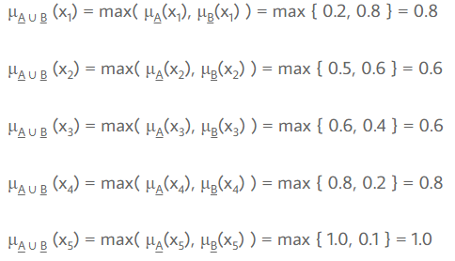

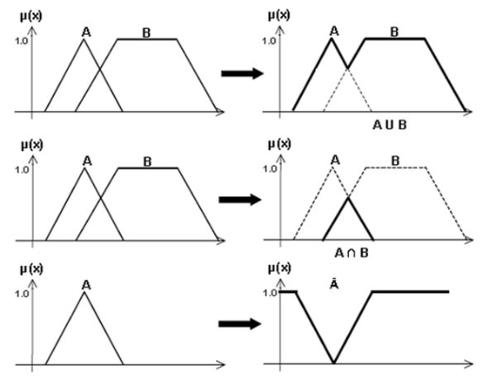

### Crisp Relation and Fuzzy Relation

### Relations are intimately involved in logic, approximate reasoning, rule based systems, nonlinear simulation, synthetic evaluation, classification, pattern recognition, and control.

### Relations represent mappings for sets just as mathematical functions do;

### Relations are also very useful in representing connectives in logic

### 

### 

### 

### 

### 

### 

### A crisp relation is used to represents the presence or absence of interaction, association, or interconnectedness between the elements of more than a set. This crisp relational concept can be generalized to allow for various degrees or strengths of relation or interaction between elements.

### Operations on Crisp Relations

Let A and B be two relations defined on X x Y and are represented by relational matrices. The following operations can be performed on these relations A and B

Union A ∪ B (x,y) = max [ A (x,y) , B (x,y) ]

Intersection A ∩ B (x,y) = min [ A(x,y) , B (x,y) ]

### Fuzzy relation - Degrees of association can be represented by grades of the membership in a fuzzy relation in the same way as degrees of set membership are represented in the fuzzy set. In fact, just as the crisp set can be viewed as a restricted case of the more general fuzzy set concept, the crisp relation can be considered to be a restricted case of the fuzzy relations.

### Cartesian product

The Cartesian product of two crisp sets X and Y, denoted by is the crisp set of all ordered pairs such that the first element in each pair is a member of X and the second element is a member of Y. Formally,

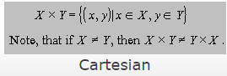

### Relation among sets

A relation among crisp sets

[relations](https://i0.wp.com/blog.oureducation.in/wp-content/uploads/2013/05/n29.gif?ssl=1)

relations

is a subset of the Cartesian product

[Cartesian product](https://i0.wp.com/blog.oureducation.in/wp-content/uploads/2013/05/n210.gif?ssl=1)

is a subset of the Cartesian product

It is denoted either by

[relations](https://i0.wp.com/blog.oureducation.in/wp-content/uploads/2013/05/n211.gif?ssl=1)

relations

or by the abbreviated form

[relations](https://i0.wp.com/blog.oureducation.in/wp-content/uploads/2013/05/n212.gif?ssl=1)

relations

Thus,

[relations](https://i0.wp.com/blog.oureducation.in/wp-content/uploads/2013/05/n213.gif?ssl=1)

relations

so for relations among sets

[ relations among sets](https://i0.wp.com/blog.oureducation.in/wp-content/uploads/2013/05/n214.gif?ssl=1)

so for relations among sets

, the Cartesian product represents

[product](https://i0.wp.com/blog.oureducation.in/wp-content/uploads/2013/05/n215.gif?ssl=1)

product

the universal set. Because a relation is itself a set, the basic set concepts such as containment or subset, union, intersection, and complement can be applied without modification to relations.

Each element of the first dimension i1 of this array corresponds to exactly one member of X1, each element of the first dimension i2 to exactly one member of X2, and so on. If the n-tuple

[ dimension i1](https://i0.wp.com/blog.oureducation.in/wp-content/uploads/2013/05/n219.gif?ssl=1)

dimension i1

,then

[membership](https://i0.wp.com/blog.oureducation.in/wp-content/uploads/2013/05/n220.gif?ssl=1)

membership

### Crisp and Fuzzy Relations

Thus, a fuzzy relation is a fuzzy set defined on the Cartesian product of crisp sets

[crisp sets](https://i0.wp.com/blog.oureducation.in/wp-content/uploads/2013/05/n221.gif?ssl=1)

Cartesian product of crisp sets

, may have varying degrees of membership within the relation. The membership grade is usually represented by a real number in the closed interval,

[0,1](https://i0.wp.com/blog.oureducation.in/wp-content/uploads/2013/05/n222.gif?ssl=1)

0,1

and indicates the strenght of the relation present between the elements of the tuple.

A fuzzy relation can also conveniently be represented by an n-dimensional membership array whose entries correspond to n-tuples in the universal set. These entries take values representing the membership grades of the corresponding n-tuples.

Examples

Let Q be a crisp relation among the two sets A={dollar, pound, franc, mark} and Y={United States, France, Canada, Britain, Germany}, which associates a country with a currency as follows:

R(A,B) = {(dollar,United States),(franc,France),(dollar,Canada),

(pound,Britain),(mark,Germany)}

This relation can also be represented by the following two dimensional membership array:

|  |  |  |  |  |  |
| --- | --- | --- | --- | --- | --- |
|  | U.S. | France | Canada | Britain | Germany |
| dollar | 1 | 0 | 1 | 0 | 0 |
| pound | 0 | 0 | 0 | 1 | 0 |
| franc | 0 | 1 | 0 | 0 | 0 |
| mark | 0 | 0 | 0 | 0 | 1 |

Let R be a fuzzy relation among the two sets the distance to the target X={far, close, very close} and the speed of the car Y={very slow, slow, normal, quick, very quick}, which represents the relational concept “the break must be pressed very strong”.

This relation can be written in list notation as

R(X,Y) = {0/(far, very slow) + .3/(close, very slow) + .8/(very close, very slow)

+ 0/(far, slow) + .4/(close, slow) + .9/(very close, slow)

+ 0/(far, normal) + .5/(close, normal) + 1/(very close, normal)

+ .1/(far, quick) + .6/(close, quick) + 1/(very close, quick)

+ .2/(far,very quick)+ .7/(close,very quick)+ 1/(very close,very quick)}

This relation can also be represented by the following two dimensional membership array:

|  |  |  |  |  |  |
| --- | --- | --- | --- | --- | --- |
|  | very slow | slow | normal | quick | very quick |
| far | 0 | 0 | 0 | .1 | .2 |
| close | .3 | .4 | .5 | .6 | .7 |
| very close | .8 | .9 | 1 | 1 | 1 |

### Binary Relation Example

[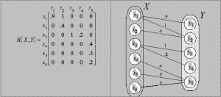](https://i0.wp.com/blog.oureducation.in/wp-content/uploads/2013/05/binary.gif?ssl=1)

**CRISP Logic, Predicate Logic, Fuzzy Logic**

1. **Crisp Logic**:
   * Also known as classical logic or Boolean logic.
   * Deals with precise and deterministic statements where propositions are either true or false.
   * Operates on the principle of bivalence, meaning every statement must be either true or false.
   * Utilizes logical operators such as AND, OR, NOT to manipulate propositions.
   * It's the foundation of traditional mathematics and computer science.
   * Example: "The sky is blue" is true, "2 + 2 = 5" is false.

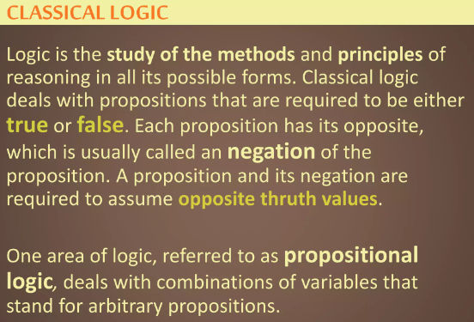

1. **Predicate Logic**:
   * Also known as first-order logic.
   * Extends propositional logic by incorporating variables, quantifiers, and predicates.
   * Allows for more expressive statements by quantifying over elements in a domain.
   * Predicates represent properties or relations that can be true or false depending on the values of variables.
   * Quantifiers like "for all" (∀) and "there exists" (∃) are used to express universal and existential quantification respectively.
   * Example: "For all x, if x is a human, then x is mortal."
   * 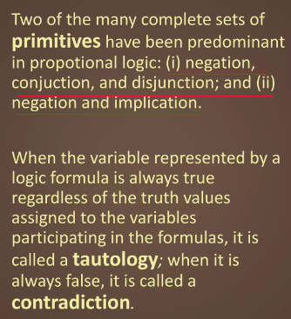

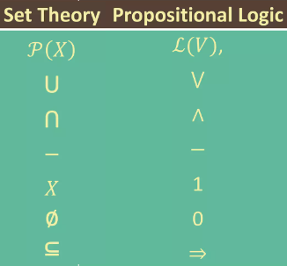

* + **Existential quantification** is a concept in logic and mathematics that refers to the assertion that there exists at least one instance of a certain property or condition within a given domain. It is denoted symbolically by the existential quantifier (∃), which is read as "there exists" or "for some."
  + For example, in the statement "There exists a prime number greater than 10," the existential quantification (∃) is used to assert the existence of at least one prime number greater than 10.
  + 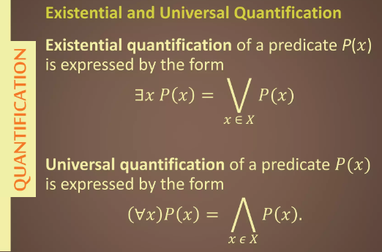
  + **Universal quantification** is another concept in logic and mathematics, but instead of asserting the existence of at least one instance of a property, it asserts that a property holds for all elements within a given domain. It is denoted symbolically by the universal quantifier (∀), which is read as "for all" or "for every."
  + For example, in the statement "For all natural numbers n, n + 1 is greater than n," the universal quantification (∀) is used to assert that the property "n + 1 is greater than n" holds for every natural number n.

1. **Fuzzy Logic**:
   * Deals with reasoning and decision-making under uncertainty or vagueness.
   * Allows intermediate values between true and false, represented as degrees of truth ranging from 0 to 1.
   * Used to model and handle imprecise information and approximate reasoning.
   * Instead of strict true/false, propositions can be partially true or partially false.
   * Utilizes fuzzy sets and linguistic variables to represent uncertainty.
   * Widely used in control systems, artificial intelligence, and expert systems.
   * Example: "The temperature is hot" might be true to some degree, say 0.8, rather than a strict true (1) or false (0).
   * 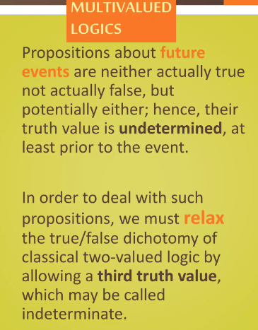
   * 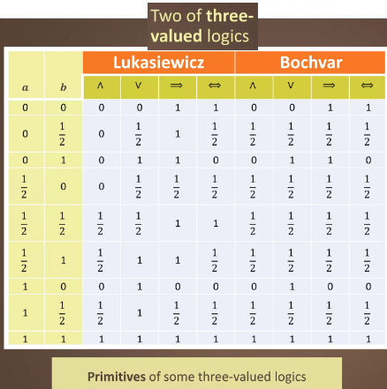

* **Łukasiewicz logic** is a type of many-valued logic that allows for the assignment of truth values beyond just true (1) and false (0). Instead, it accommodates a range of truth values, often represented by real numbers between 0 and 1, where 0 corresponds to falsity and 1 corresponds to truth, with intermediate values representing degrees of truth or falsity.

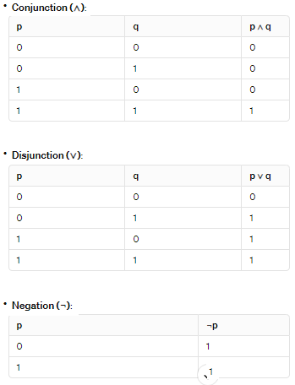

* **Bochvar's** three-valued logic extends classical two-valued logic by introducing a third truth value, often denoted as "unknown" or "indeterminate," alongside the traditional "true" and "false" values. This logic allows for reasoning in situations where propositions may not have a clear-cut truth value, such as when information is incomplete or ambiguous.

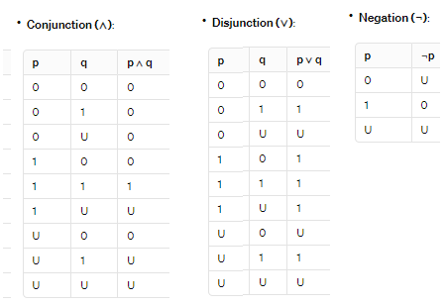

In summary, crisp logic deals with precise true/false statements, predicate logic extends this to handle variables and quantifiers, and fuzzy logic deals with reasoning under uncertainty by allowing for degrees of truth. Each type of logic has its own applications and is suited to different problem domains.

**FUZZY QUANTIFIER**

In fuzzy logic, fuzzy quantifiers play a significant role in expressing the degree of truth of propositions over a range of values. Unlike classical logic, which deals with crisp, binary truth values (true or false), fuzzy logic allows for the representation of uncertainty and vagueness by assigning degrees of truth to propositions.

Fuzzy quantifiers are used to describe the extent to which a property or relationship holds within a set or domain. They are particularly useful in situations where precise boundaries between categories are difficult to define, such as in natural language processing, decision-making systems, and expert systems. Here are some common fuzzy quantifiers used in fuzzy logic:

1. **Existential Quantifiers** ∃ :
   * Represent the degree to which a property or relationship exists within a set.
   * Example: "Some," "There exists."
   * Example usage: "Some cats are black." This statement expresses that there are black cats to some extent within the set of cats.
2. **Universal Quantifiers** ∀:
   * Represent the degree to which a property or relationship holds for all elements in a set.
   * Example: "All," "Every."
   * Example usage: "Every student is diligent." This statement suggests that every student possesses the quality of being diligent to some extent within the set of students.
   * ∀xP(x) is read as for every value of x, P(x) is true.
3. **Hedges**:
   * Modifiers used to adjust the strength of a fuzzy quantifier, indicating the degree of membership in a fuzzy set.
   * Example: "Very few," "Almost all."
   * Example usage: "Almost all apples are red." This statement implies that a large proportion of apples are red, but not necessarily all of them.

Fuzzy quantifiers allow for a more nuanced representation of uncertainty and vagueness in reasoning and decision-making processes. They enable fuzzy logic systems to model complex real-world situations where precise categorization is challenging. By assigning degrees of truth to propositions, fuzzy quantifiers provide a flexible framework for handling imprecise information and approximate reasoning.

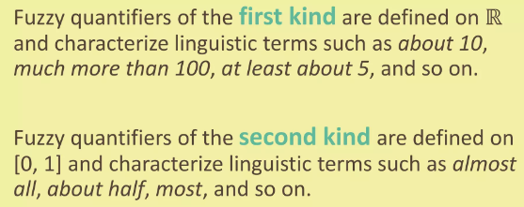

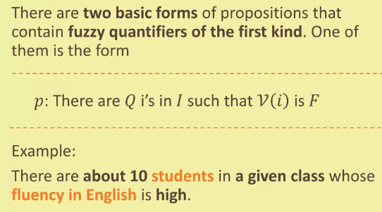

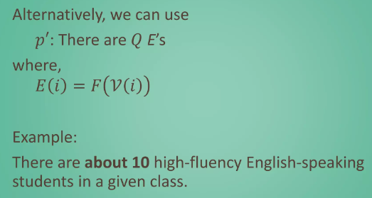

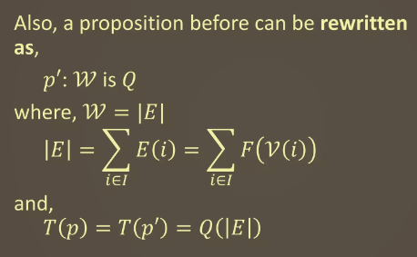

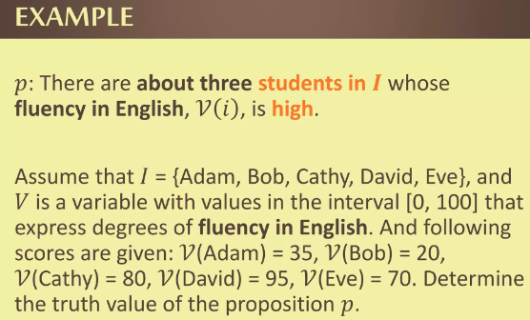

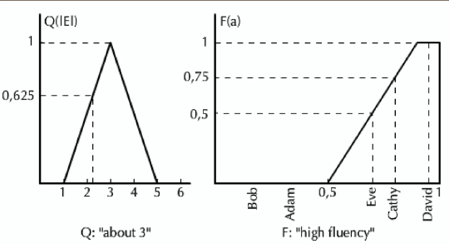

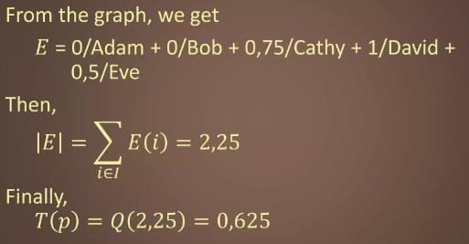

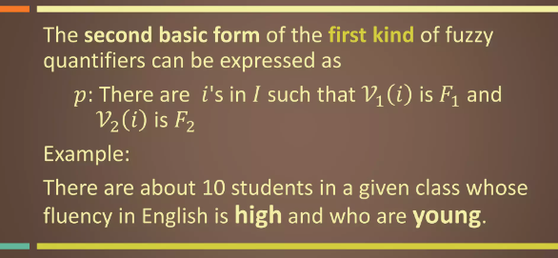

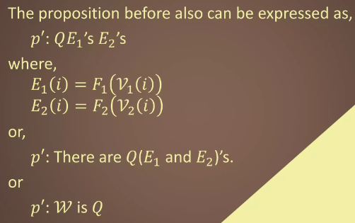

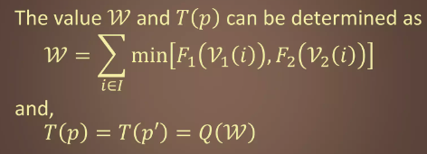

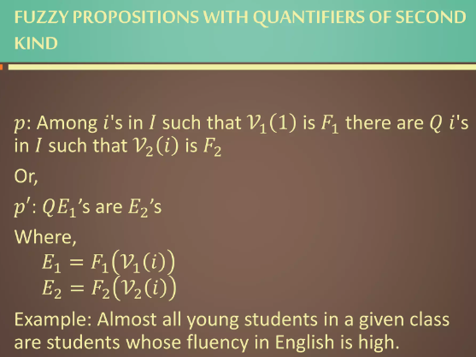

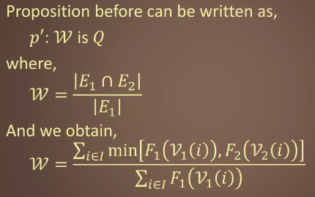

<https://www.slideshare.net/YosepKristanto/fuzzy-logic-36638334>

**Fuzzy Logic and Inference:** Crisp Logic, Predicate Logic, Fuzzy Logic, Fuzzy Quantifiers, Fuzzy Inference, Fuzzy knowledge and rule-based system, fuzzy decision making, Defuzzification.

**Fuzzy Rules**

**Classical Implication**

In logic, the arrow symbol "->" typically represents the material implication or conditional operator. It is commonly used to express logical implication, where one statement (the antecedent) implies another statement (the consequent). The truth table for the "->" operator is as follows:

In the truth table:

* "p" represents the antecedent or the premise.
* "q" represents the consequent or the conclusion.
* "T" stands for true.
* "F" stands for false.

The material implication "p -> q" is true in all cases except when the antecedent "p" is true and the consequent "q" is false. This reflects the idea that if the antecedent is true and the consequent is false, the implication is considered false; otherwise, it is true.

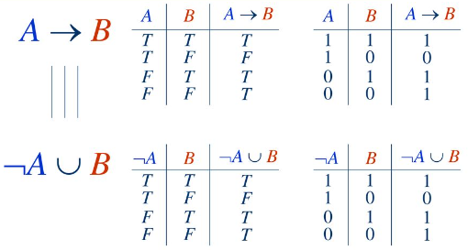

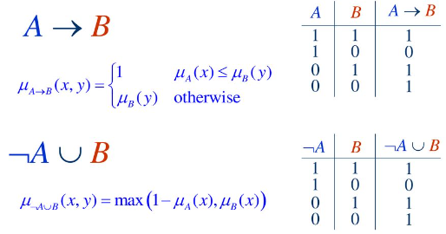

In logic, the symbol "=>" is often used to represent logical implication or conditional statements, similar to "->". However, its usage can vary depending on the context or the specific logical system being used.

For example, in propositional logic or predicate logic, "=>" typically denotes material implication, just like "->". It represents the relationship between a premise (antecedent) and a conclusion (consequent), where the truth of the premise implies the truth of the conclusion.

The truth table for "=>" in classical propositional logic is the same as for "->"

In logic, the symbol "<=>" typically represents the biconditional operator, also known as "if and only if" or "iff". The biconditional operator expresses that two statements are logically equivalent, meaning that they have the same truth value under all interpretations.

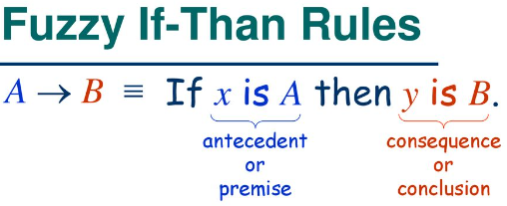

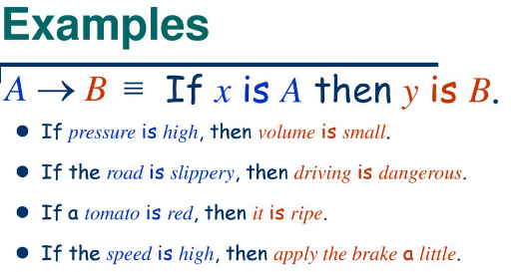

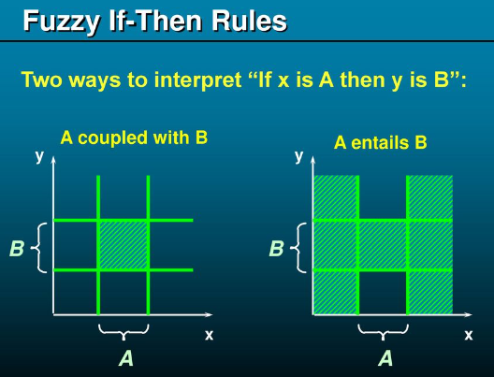

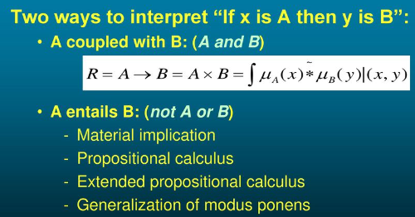

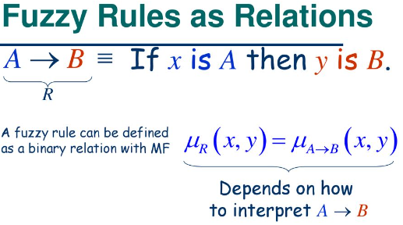

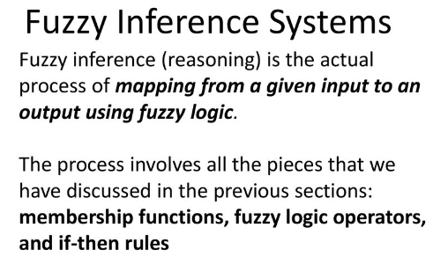

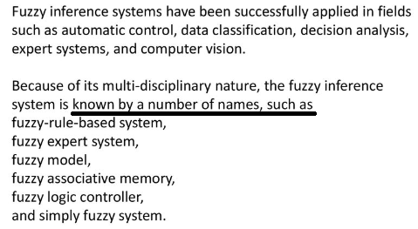

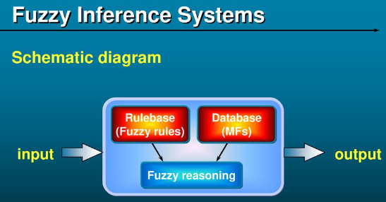 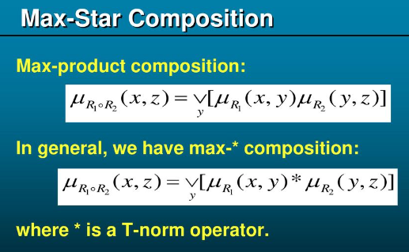

Fuzzy inference systems (FIS) are computational frameworks used for modeling and implementing systems that can make decisions based on imprecise, uncertain, or vague information. They are particularly useful in situations where traditional binary logic or precise mathematical models are inadequate for representing complex, uncertain, or ambiguous relationships.

Here's a breakdown of how fuzzy inference systems work:

**Fuzzification:** FIS begins by converting crisp (precise) input values into fuzzy sets. Fuzzy sets represent degrees of membership rather than strict membership, allowing for the representation of uncertainty or vagueness in the input.

**Fuzzy Rule Base**: FIS employs a set of fuzzy rules to capture expert knowledge or domain-specific heuristics. These rules are typically in the form of "if-then" statements, where the antecedent (if-part) describes conditions in terms of fuzzy sets, and the consequent (then-part) describes the action or decision also in terms of fuzzy sets.

**Inference Engine:** The inference engine of the FIS **evaluates** the fuzzy rules based on the fuzzy input values and determines the degree to which each rule contributes to the overall decision-making process. This process involves combining the fuzzy input values with the fuzzy rules to derive fuzzy outputs.

**Aggregation:** Once the fuzzy outputs are obtained from individual rules, they are aggregated to form a single fuzzy output set. This aggregation step combines the fuzzy outputs from different rules, often using operations such as maximum or weighted average.

**Defuzzification:** The final step in a fuzzy inference system is defuzzification, where the fuzzy output set is converted back into a crisp output value. This process aims to obtain a single, meaningful output value from the fuzzy output set, typically by calculating its centroid or using other techniques such as the maxima method.

Fuzzy inference systems find applications in various fields such as control systems, pattern recognition, decision-making, and artificial intelligence, where dealing with uncertainty or imprecision is essential for effective problem-solving. They provide a flexible and intuitive framework for modeling and implementing intelligent systems capable of handling real-world complexities.

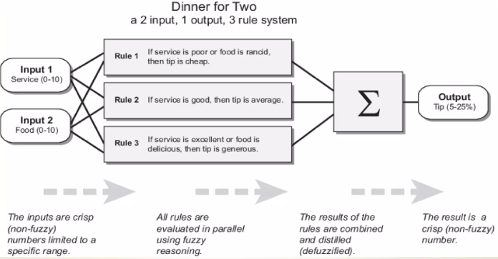

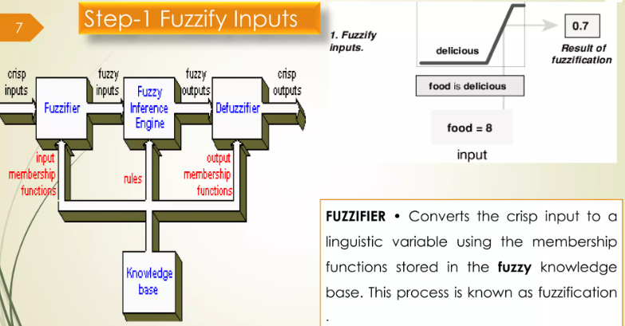

**A linguistic variable** is a concept used in fuzzy logic and fuzzy set theory to represent variables whose values are not fixed but rather described linguistically using natural language terms. Unlike traditional variables in mathematics, which take precise numerical values, linguistic variables allow for the representation of imprecise or vague information.

**Membership Functions:** Membership functions define the shape and characteristics of the fuzzy sets associated with linguistic variables. These functions map input values to degrees of membership in the fuzzy sets, capturing the fuzziness or uncertainty inherent in linguistic variables.

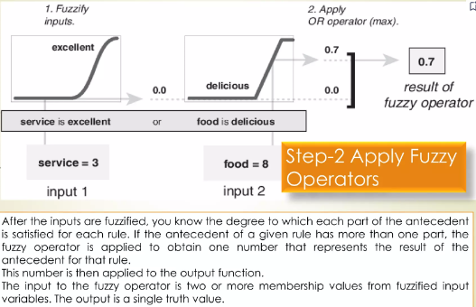

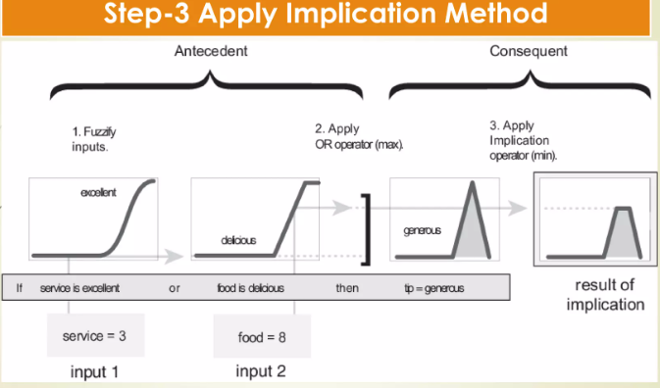

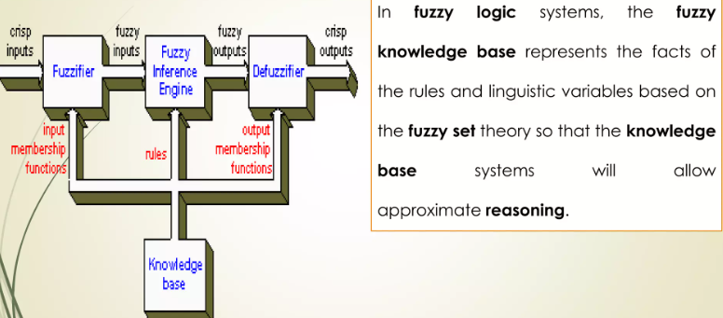

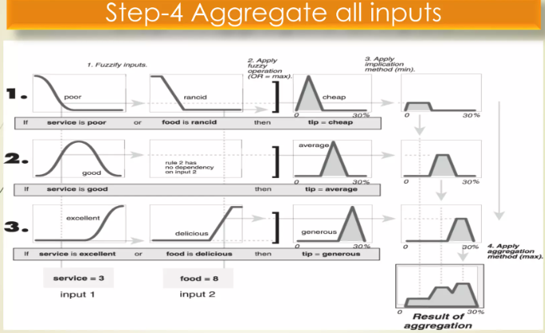

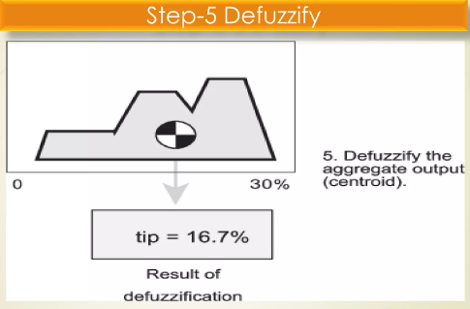

**FUZZY KNOWLEDGE-BASED SYSTEM**

A fuzzy knowledge-based system (FKBS) combines the principles of fuzzy logic with knowledge representation techniques to handle imprecise, uncertain, or vague information. These systems are particularly useful when dealing with complex domains where precise mathematical models are impractical or impossible to define. 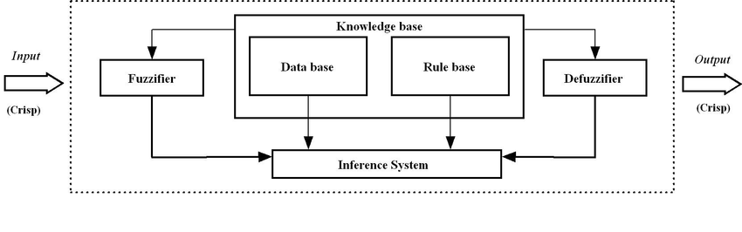

**Fuzzy Logic:** Fuzzy logic provides a mathematical framework for representing and reasoning with uncertain or imprecise information. It extends classical binary logic by allowing degrees of truth between 0 and 1, enabling the representation of vague or fuzzy concepts.

**Knowledge Representation:** In FKBS, knowledge about the domain is represented using fuzzy sets, linguistic variables, and fuzzy rules.

* Fuzzy sets represent vague concepts,
* linguistic variables describe the variables in the domain using natural language terms, e.g., ("low," "medium," "high")
* fuzzy rules capture expert knowledge or heuristics in the form of "if-then" statements.

**Rule-based Systems:** Rule-based systems are a key component of FKBS. These systems consist of a set of rules that govern the behavior or decision-making process within the system. Each rule typically has an antecedent (conditions) and a consequent (action), and they are evaluated based on the current state of the system.

**Fuzzy Inference Engine:** The fuzzy inference engine is responsible for applying the fuzzy rules to the input data and generating appropriate output. It combines the fuzzy rules with the current state of the system to infer fuzzy conclusions, which are then used to guide the system's behavior or decision-making.

**Example:** Consider a fuzzy knowledge-based system for controlling the temperature of a room.

The system may have fuzzy rules such as

* "if the room temperature is cold and the outside temperature is cold, then increase the heater level"

or

* "if the room temperature is warm, then decrease the heater level."

These rules combine fuzzy input variables (e.g., room temperature, outside temperature) with linguistic terms (e.g., cold, warm) to make decisions about adjusting the heater level.

In summary, fuzzy knowledge-based systems leverage fuzzy logic and rule-based systems to model and reason with imprecise or uncertain information in complex domains, enabling more robust decision-making and control in real-world applications.